# Computer Organization Architecture Lab-KCS-452_2022

**ABHISHEK RAJ0UT**

2100290120007

**IMPLEMENTATION OF LOGIC GATES USING NAND GATE**

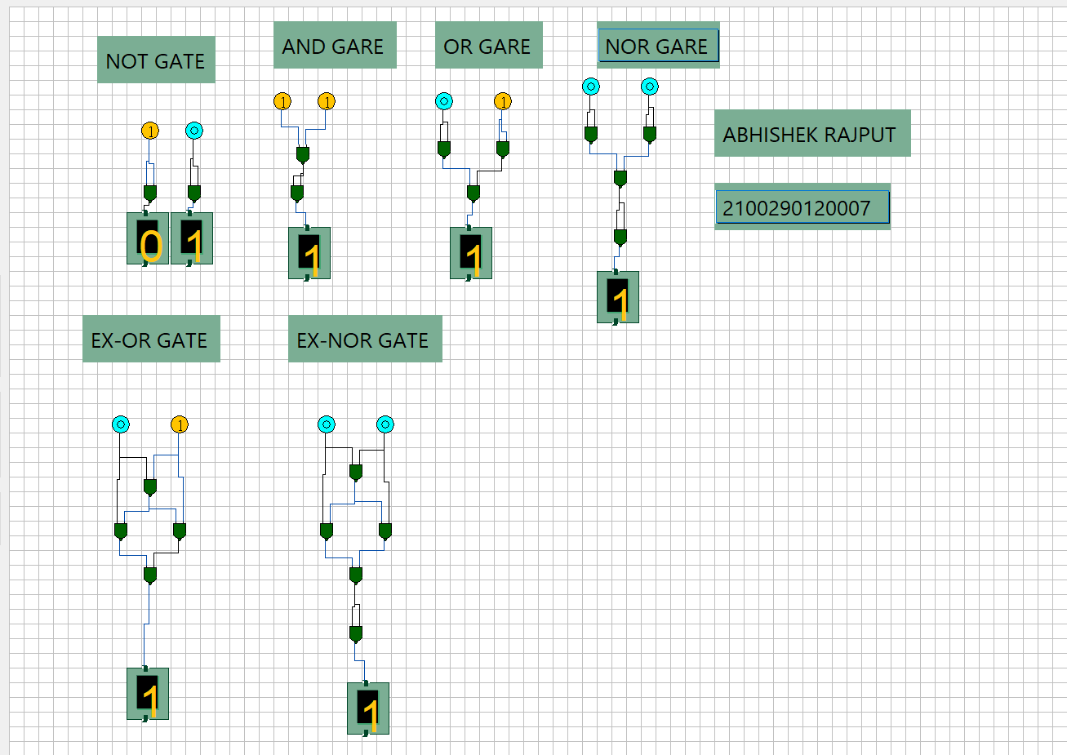

**IMPLEMENTATION OF LOGIC GATES USING NOR GATE**

